**User Manual**

**For**

**Pyoneer**

**Krystian Jankowski**

**OnchieVillaver**

Table of Contents

General Information 2

System Overview 2

Points of Contact 2

Tutorial 2

Starting Tutorial 2

Exam 3

Starting Exam 3

Passing an Exam 3

Snake Section 4

Pyoneer Snakes Game 4

Snake World 4

Starting a Level 4

Changing Language 7

Shortcuts 7

Help 8

Snake Speed 8

Snake Color 8

About 8

Status Bar 9

# General Information

## System Overview

The purpose of this application is to teach secondary students to learn how to program in Python, a computer language.This document will give you the knowledge about how to use the application.The application has two main parts, a tutorial section where you learn the basics of programming. The second part is a snakes game, where you have to come with a solution how to navigate the snake, this is problem solving.

The Tutorial part has six sections covering different topics, after each topic you have to answer five questions. You need to have at least four correct answers in order to proceed to the next topic. At the end of the tutorial part there is final set of questions which consists of questions from different topics.

The snake game part of the application has four levels, for the student to solve. You click the “Level” option on the menu bar and pick the level you want to solve. The student is advised to start at level one. To solve a level click the “Function” option in the menu bar, and pick a method that the snake will do. The methods are:

* MoveUp() – causes the snake to move one cell upwards.
* MoveDown() – moves the snake one cell downwards.
* MoveRight() – moves the snake one cell to the right.
* MoveLeft() – moves the snakes one cell to the left.
* Wait() – the snake waits.

## Points of Contact

If you have any questions or queries about this application you can contact the developers by going to the Pyoneer’s official site <http://pyoneer.a-spark.co> .

# Tutorial

## Starting Tutorial

There are two ways of doing this after starting the program.

Method One

1. Click on the “File” menu.
2. Click “Start Tutorial”. Note that “Start Tutorial” has a start icon beside it, to make the program easier to use.

Method Two

1. Run the Program. This will show the Welcome page.
2. Click the “Start Tutorial” button.

## Exam

The purpose of this element in the program is for you to ensure that you’re learning something.

## Starting Exam

1. After reading the text on the chapter click on the “Exam” button. This will cause five single choice dialogs to appear consecutively containing the questions and choices. The choices are labeled (a), (b) and (c) as you are accustomed to in school.

## Passing an Exam

1. It is strongly advised that you read carefully the chapter before attempting to answer the test. Each point made in the tutorial sections has at least one example.
2. It is very important to remember the keywords and characters in programming such as if, else , while, for,< , >>=, <=, etc.

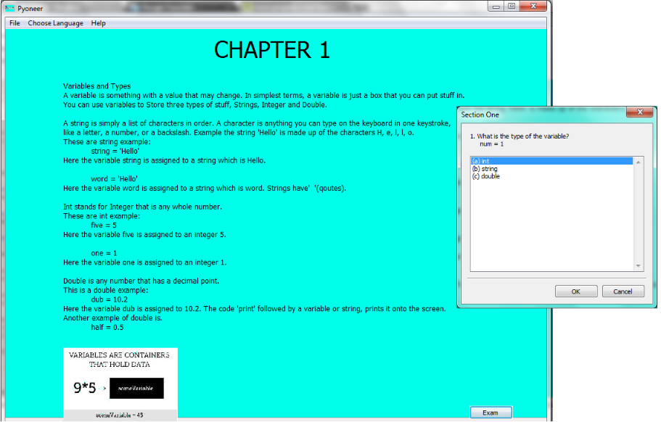

1. You could drag the mini frame to any side you want, so you could refer to the notes while trying to answer a question.
2. Take a look at the picture in each chapter they give a graphical representation of the cencepts being taught.

# Snake Section

## Pyoneer Snakes Game

To access this part of the program you need to pass the Tutorial sections. If you get to this stage, Well Done! you now know the basic concepts of programming. In this part of the program you have to come up with sulotions to test your problem solving skills.

You pick a level to solve, a picture then will appear on the right hand side panel, an image of the snake and the environment he’s in. With this image you have a guide about wich methods to pick, in order for the snake to get to the tressure a raspberry which is colored red.

## Snake World

* Snake – this is the actor of the game. It’s color white. Goals are:
  + Get to the tressure.
  + Avoid Wall.
* Tressure – the main goal of the snake. Is usually located around walls.
* Wall - this are the obstacles in the Snake World. If the snake hits it, it is Game Over.

## Starting a Level

1. To start, first click “Choose Level” and pick Level 1, it is recommended to pick this one before trying the other ones.
2. Compose a list of moves the snake will do. Click on the “Function” menu and pick a move you think will be useful to solve the level. A message will pop out asking you, if are you sure abou the move you picked. If you are, just click “Ok”.
3. Once you have composed your sequence of methods, click on “File” and click on “Run Level 1” to try out your code. If your sequence of methods is right you’ll hear a positive sound and see a green text “Level Completed.”.
4. If you want to proceed to the other levels, just do the same steps from Level 1.

There are many ways to complete a level but always remember that the point of this part of the program is to test your problem solving skills, so you have to make up the shortest possible path for the snake to get to the tressure.

The following images are the the different Snake Levels with sample code(Not Solution):

**Level 1**

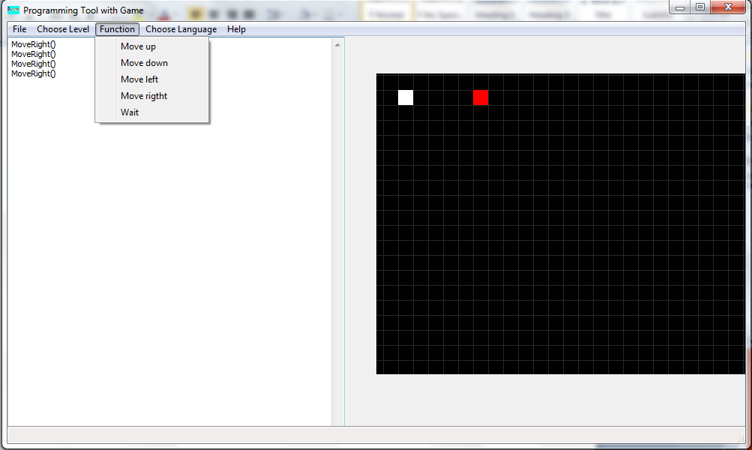

**Level 2**

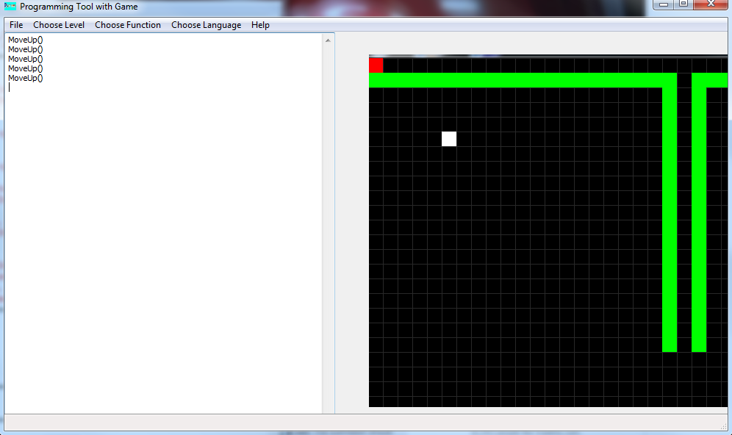

**Level 3**

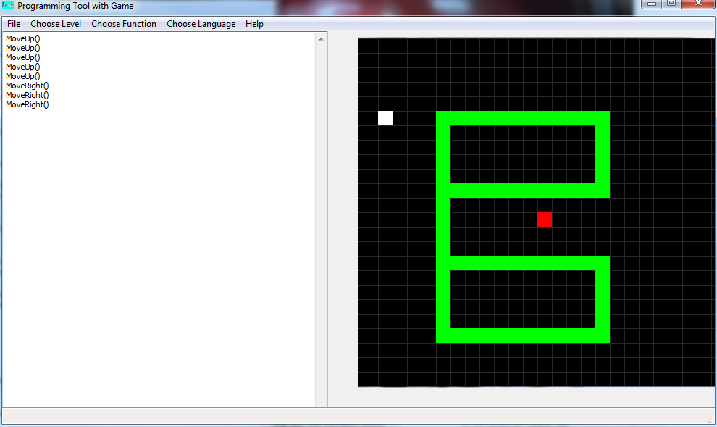

**Level 4**

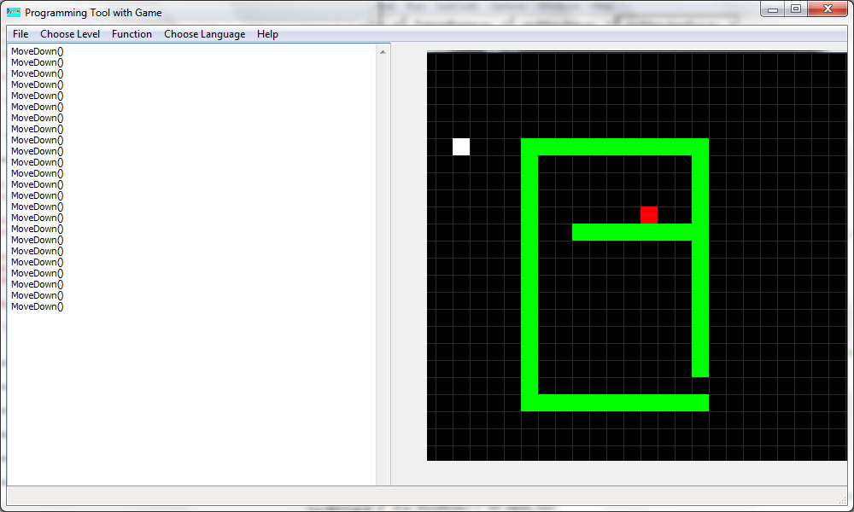

# Changing Language

If English is not you’re native language or if you prefer to learn Python in a different language, no problem, you can change the language of Pyoneer. You can choose from three languages, English, Polish or Filipino. This is done by doing the following easy steps:

1. Click on the “Choose Language” menu in the menu bar.
2. Click on the language you want.
3. Do the same steps if you’re in the Snakes game.

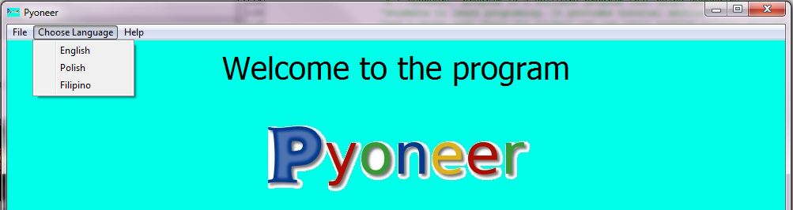

Shortcuts

For advanced users, shortcuts are available to allow them to navigate through the program faster. The following shortcuts are available:

Ctrl + R - Begins the Tutorial C:\Users\Ching\Desktop\PROJECT\User Manual\Shortcut R.png

Ctrl + X - Terminates the Program C:\Users\Ching\Desktop\PROJECT\User Manual\Shortcut X.png

Ctrl + H - Opens the Help- C:\Users\Ching\Desktop\PROJECT\User Manual\Shortcut Help.png

Ctrl + E – If you’re in one of the sections, this shortcut allows you to start the exam.

Ctrl + 1 - This runs level 1.

Ctrl + 2 - This runs level 2.

Ctrl + 3 - This runs level 3.

Ctrl + 4 - This runs level 4

# Help

This menu allows you to change the travel speed of the snake, change the color theme of the Snake World and get more information about the Pyoneer.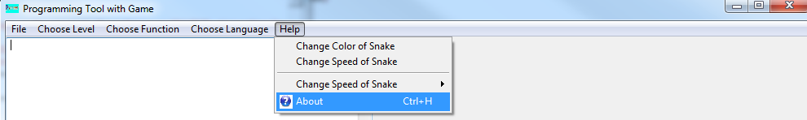

## Snake Speed

Clicking on the “Change Speed of Snake” shows a sub menu of numbers 1 – 10. When you run the level then, the snake will run at the speed you’ve chosen.

## Snake Color

Clicking on the “Change Color of Snake” changes the color of the snake, into brown.

## About

The About option will give you a very brief information about Pyoneer. The user can find more information about the program by clicking the “About” option. It will cause this frame to appear.

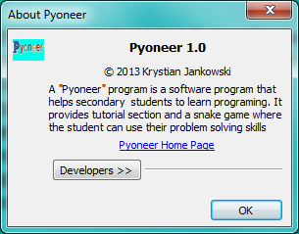

A web link “Pyoneer Home Page” is present. If clicked, your computer will open your default web browser and open a site about the program. The following documents are available in the site:

* Functional Specifications
* Technical Specifications
* Manual

## 

## Status Bar

This bar is located at the bottom of the program. It acts as a guide by displaying a text what the options in the menu will do if you click it. The status bar is activated by hovering, your mouse cursor over the options. Example: Cursor is hovering at an option and the status is “Move snake one cell left”.

